Dynamic Multi-Spectral Adversarial Camouflage Pattern Generation for Adaptive Object Concealment in Visible and Infrared Domains

GOUTAM DEBNATH

RESEARCH PROPOSAL

MARCH 2026
ABSTRACT
The recent times have seen astronomical advancement in the deep-learning based object detection systems, especially in the visible and the infrared (IR) spectra. This has significantly reduced the effectiveness of conventional camouflage strategies. Modern day surveillance systems employ multi-spectral sensing, enabling robust detectability under varying environmental and illumination conditions. Although adversarial machine learning systems have given birth to multiple methods and frameworks that generate carefully optimized patterns which can successfully mislead even the best state-of-the-art object detectors, existing approaches primarily focus on static perturbations within a single spectral domain and rarely consider dynamic motion or cross-spectral consistency.
This research proposes MS-DACS (Multi-Spectral Dynamic Adversarial Camouflage System), a motion-aware framework for generating adaptive camouflage patterns designed to attack both the visible and the infrared domains. MS-DACS models object dynamics using temporal bounding box displacement and scale variation, which are used to condition a generative network for frame-wise camouflage pattern synthesis. A multi-objective optimization strategy integrates detection suppression, spectral consistency and temporal smoothness constraints to ensure realistic and stable pattern generation across consecutive frames
The proposed system will be evaluated using the KAIST Multispectral Pedestrian Dataset by Hwang et al. (2015), with performance assessed through detection confidence reduction, attack success rate, and robustness under dynamic motion scenarios. By integrating motion modelling with multi-spectral adversarial optimization, MS-DACS advances intelligent camouflage design beyond static perturbation methods toward adaptive, sensor-aware concealment mechanisms.

TABLE OF CONTENTS
LIST OF FIGURES 5
LIST OF TABLES 6
LIST OF ABBREVIATIONS 7
1. INTRODUCTION 9
1.1. BACKGROUND OF THE STUDY 9
1.2. PROBLEM STATEMENT 9
1.3. AIM AND OBJECTIVES 9
1.4. RESEARCH QUESTIONS 10
1.5. SCOPE OF STUDY 10
1.6. SIGNIFICANCE OF STUDY 11
1.7. STRUCTURE OF STUDY 11
2. LITERATURE REVIEW 12
3. METHODOLOGY 14
3.1. MULTISPECTRAL DATASET PREPARATION 16
3.2. OBJECT DETECTION AND TARGET REGION INDENTIFICATION 16
3.3. BACKGROUND CONTEXT EXTRACTION 17
3.4. CONTEXT CONDITIONED CAMOUFLAGE PATTERN GENERATION 19
3.5. CAMOUFLAGE TEXTURE APPLICATION 20
3.6. DETECTOR EVALUATION AND ADVERSARIAL FEEDBACK 20
3.7. OPTIMIZATION AND MODEL TRAINING 20
4. ANALYSIS 21
4.1. INTRODUCTION 21
4.2. DATA ANALYSIS 21
4.3. HYPERPARAMETER TUNING 25
4.4. EXPERIMENT DETAILS 26
4.5. SUMMARY 27
5. RESULTS AND DISCUSSIONS 27
6. CONCLUSIONS AND RECOMMENDATIONS 29
REFERENCES 29
APPENDIX 31

LIST OF FIGURES
Figure 3.1 Overall framework of the research methodology--------------------------------------12
Figure 3.1.1 Samples of prepared paired dataset----------------------------------------------------13
Figure 3.2.1 Detections by YOLOv8 and Faster R-CNN------------------------------------------14
Figure 3.3.1 Expanded bounding box-----------------------------------------------------------------15
Figure 3.3.2 Background context----------------------------------------------------------------------16
Figure 4.2.1 Bar plot distribution of images with vs without pedestrians------------------------21
Figure 4.2.2 Histogram plot of height, width and area of bounding boxes-----------------------22
Figure 4.2.3 Box plot of height, width and area of bounding boxes-------------------------------22
Figure 4.2.4 Dominant colours found in the background-------------------------------------------22
Figure 4.2.5 RGB pixel intensity distribution--------------------------------------------------------23
Figure 4.2.6 Thermal intensity distribution-----------------------------------------------------------23
Figure 4.2.7 Histogram plot of number of pedestrians per image---------------------------------24
Figure 4.2.8 Histogram plot of confidence scores---------------------------------------------------24

LIST OF TABLES
Table 4.3.1 List of hyperparameters--------------------------------------------------------------------24
Table 4.4.1 List of Libraries/softwares and their versions------------------------------------------26

LIST OF ABBREVIATIONS
MS-DACS – Multi-Spectral Dynamic Adversarial Camouflage System
CNN – Convolutional Neural Network
R-CNN – Region-based Convolutional Neural Network
IR – Infrared
RGB – Red-Green-Blue
LiDAR – Light Detection And Ranging
RADAR – Radio Detection and Ranging
YOLO – You Only Look Once
TPM – Tri planar Mapping
GAN – Generative Adversarial Network
cGAN – Conditional Generative Adversarial Network
mAP – Mean Average Precision
LPIPS - Learned Perceptual Image Patch Similarity
ASR – Attack Success Rate
CPU – Central Processing Unit
GPU – Graphics Processing Unit
RAM – Random Access Memory
VRAM – Video Random Access Memory
SSD – Solid State Drive
RTX - Ray Tracing Texel eXtreme
LTS – Long-Term Support

INTRODUCTION

BACKGROUND OF THE STUDY
Camouflage has long been considered one of the most efficient and effective survival strategies in nature. It allows organisms to avoid predators or approach prey without being detected. Gerald H. Thayer and Abbott H. Thayer (1909) in their work described in great details the several mechanisms used by creatures. Countershading, Disruptive Colouration and Background matching are few to name, which greatly reduce the ability to detect the creatures visually. Cott (1940) in his work expanded further on the concepts put forward by his predecessor. He analysed additional disruptive strategies, such as Masquerade, Mimicry and Warning Colouration. Natural occurrences such as these have greatly influenced humanity to design their own version of camouflage system, albeit artificially, which can be employed in the military and surveillance domain.

PROBLEM STATEMENT
The challenge to remain hidden in plain sight is in itself already a tough endeavour. Developments in the field of Deep Learning have brought forward detection systems that can work not only in the visible (RGB) spectrum, but also in the infrared or thermal spectrum. With such systems widely distributed and running in the military and surveillance domain. The traditional camouflage systems primarily employed by humans depend on static colour and texture blending. However, faced with such advanced technologies, these traditional methods become obsolete. Furthermore, existing adversarial camouflage approaches primarily rely on static textures that remain fixed once generated. Such methods do not adapt to changes in object movement or surrounding environmental conditions, limiting their effectiveness in dynamic multi-spectral scenarios. Therefore, there is a need for an adaptive camouflage framework capable of generating context-aware camouflage patterns across visible and infrared domains.

AIM AND OBJECTIVES
The aim of this research is to develop a framework that generates dynamic multi-spectral camouflage patterns for object concealment in visible as well as infrared domain by considering object motion and the surrounding background context.
Our objectives are to prepare and preprocess the KAIST dataset by Hwang et al. (2015). Then we will run detections on the dataset, extract the bounding box coordinates of the pedestrians and extract the background context. Next, we will design the dynamic multi-spectral camouflage pattern generation framework that generates camouflage patterns based on the object motion and background context. We will then evaluate the effectiveness of the generated pattern against pretrained object detectors. Finally, we shall analyse the robustness of the proposed framework using various evaluation metrics as well as compare its performance with the existing camouflage approaches.

RESEARCH QUESTIONS
Through this research, we are aiming to find answers to the following questions:
- Can adaptive camouflage generation improve object concealment compared to the existing static camouflage pattern generators in the visible and infrared domains.
- Does introducing object motion and background context improve the effectiveness of camouflage pattern generation and improve overall object concealment
- How effective is the proposed framework against pre-trained object detectors across visible and infrared domains
- How robust is the proposed framework under dynamic scene conditions when evaluated using detection based performance metrics.

SCOPE OF STUDY
This research focuses on developing a dynamic multi-spectral camouflage pattern generation framework for adaptive object concealment in visible and infrared domains. The research primarily considers pedestrian objects using the KAIST dataset by Hwang et al. (2015).
The proposed framework will be implemented and evaluated entirely within a simulated environment. Dynamic conditions will be implemented using the continuous frames provided innately in the dataset.
This study is strictly limited to visible (RGB) and thermal (IR) images and does not consider additional modalities such as LiDAR, radar or hyperspectral imaging. Evaluation of the framework will be performed using pretrained object detection models in visible and infrared domains.
Furthermore, this study focuses on software based adversarial camouflage and evaluation. Physical implementation, real-world application or deployment and hardware based adaptive camouflage systems are outside the scope of this study.

SIGNIFICANCE OF STUDY
The significance of the research lies in exploring adaptive adversarial camouflage for multi-spectral object detection systems. Existing approaches are predominantly static and fail to maintain their efficiency when the object moves though changing backgrounds. By introducing a framework that generates camouflage patterns based on the object movement and background context, this study aims to contribute towards addressing a major limitation in the existing adversarial camouflage research.
From an academic point of view, this research aims to extend the existing knowledge in adversarial machine learning by introducing motion-aware and background context aware camouflage generation in a multi-spectral setting. This study also contributes to understanding how dynamic camouflage strategies affect the performance of object detection systems operating in multi-spectral setting.
From a practical perspective, the findings may help researchers and developers to evaluate the robustness and vulnerabilities of modern object detection systems used in surveillance, autonomous systems and security related applications. Understanding such vulnerabilities might help develop a more reliable and resistant detection model.
The proposed framework may also serve as foundation for future studies on adaptive adversarial camouflage generation systems, both in software-based as well as in the hardware-based fields.

STRUCTURE OF STUDY
This report is organised into 4 main chapters.
Chapter 1 focuses in introducing the research topic and provides a background of the study. The chapter also provides with the problem statement, aim and objectives of this research, scope of the study as well the significance of this study.
Chapter 2 presents a review of the existing relevant literature associated with camouflage techniques, adversarial machine learning, object detection systems in multi-spectral settings and existing camouflage approaches. The chapter also defines the research gap that motivates this study.
Chapter 3 describes the research methodology adopted in this study. The chapter presents in details the process of dataset selection process, data preprocessing, and dataset creation. We also explain in detail the object detection and background context extraction process and finally the camouflage pattern generation process and the metrics chosen for the evaluation process and the reason behind choosing them.
Chapter 4 is focused on drawing conclusions of the research. The chapter contains the evaluation results of the research as well as an overview of the framework’s performance and effectiveness compared to the existing researches and solutions publicly available.
Finally the report concludes with a list of references and any supporting appendices containing supplementary materials relevant to the research.

LITERATURE REVIEW
Research on camouflage has been going on for decades, with researchers trying to achieve something close to invisibility. Hwang et al. (2015) were one of the first to introduce in their paper the ability to detect pedestrians in visible and infrared spectrums. Ever since, researchers have strived to introduce camouflage systems to fool such detection algorithms.
One of the first such success came from Brown et al. (2018) where they would replace a part of an image(object) with their patch(sticker). The results were fed to a Whitebox-Single model, Whitebox-Ensemble and Blackbox, which successfully broke the classifiers.
While Brown et al. (2018) only attacked the classifiers, causing a wrong class to be inferenced, Liu et al. (2018) furthered the work by not only ensuring a wrong image-level classification, they also attacked the bounding box regression to disable their prediction. In their paper, the default patch was a 40 – by – 40 square, attached to the top-left corner of the image. YOLO and Faster R-CNN failed to recognize any objects when fed with the resultant image. Liu et al. (2018) also proved the transferability of their attack where the YOLO-trained patch had successfully disabled Faster R-CNN.
Chen Shang-Tseand Cornelius (2019) introduced ShapeShifter, a robust targeted attack on image-based object detectors, by adapting the Expectation over Transformation technique originally proposed for image classification. In their paper, Chen Shang-Tseand Cornelius (2019) generated adversarially perturbed stop signs that were mis-detected by Faster R-CNN. Thys et al. (2019) then in their paper, generated adversarial patches that were used to attack person detection. They used the Inria dataset, which were targeted more towards full-body pedestrians and for the detector, Thys et al. (2019) used the YOLOv2 object detector.
Duan et al. (2020) took a very different approach in their paper, where they introduced Adversarial Camouflage (AdvCam) which integrated natural styles onto the adversarial examples. This provided a unique approach where while Brown et al. (2018) and their successors generated a patch that was easily identified by human observers, patches by Duan et al. (2020) appeared legitimate to humans, yet stayed “hidden” to object detectors. Duan et al. (2020) achieved this by developing a mechanism such that the attacker can flexibly decide on the attack region and/or the attack style which then generates the final adversarial image.
Zhu et al. (2021) in their paper focused on thermal (IR) attacks instead of visible spectrum like their predecessors. The methodology used by Zhu et al. (2021) in their paper was to introduce a board strewn with small light bulbs. They attacked state-of-the-art pedestrian detector based on YOLOv3, which caused the average precision (AP) to drop by 64.12% in the digital world and by 34.48% in the real world.
With adversarial camouflage brewing up a storm in the research domain, Suryanto et al. (2023) came up with the Adversarial Camouflage for Transferable and Intensive Vehicle Evasion (ACTIVE) framework, focused on vehicles. In their paper, Suryanto et al. (2023) used Tripalanar Mapping (TPM) to apply the textures on the objects. They have also implemented Stealth Loss, Smooth Loss and Camouflage Loss for proper evaluation.
Talas et al. (2020) introduced a novel method of generating camouflage patterns using Generative Adversarial network (GAN), where patterns generated after more iterations were harder to detect with the generator reaching optimal solution at around 5000 iterations. In 2024, came a paper named “CamoDiff” by Nguyen et al. (2024) where they proposed a few-shot diffusion-based method for camouflage pattern generation. The method was indeed revolutionary where the patterns generated had an average mAP as low as around 8.2.
Wei et al. (2024) proposed a transferable adversarial attack method in their paper. They designed a classification probability loss based on inter-class probability distribution and an IoU loss function based on the predicted bounding box to train their pattern generator. Wei et al. (2024) in the paper claimed that when the generated pattern was applied to the hood of the cars, there was a staggering 91.2% and 90.7% reduction in car detection respectively against YOLOv3 detector.
Even though camouflage is a technique used for stealth, having a patch/pattern applied to a static object often loses its meaning when the object needs to be moving. The Dynamic Adversarial Patch by Hoory et al. (2020) introduced the dynamic nature into the adversarial patch where the adversarial patch would be applied to the object on pre-determined locations. The dynamic attack was implemented by switching the appropriate patches on the object according to the camera’s position, i.e. the detector’s location. When tested on the YOLOv2, the detector was misled in 90% of the video frames. Hoory et al. (2020) also claimed it to be highly transferable among other car models with where the detector was successfully misled about 71% of the time.
Zhu et al. (2025) further improved Hoory et al. (2020)’s work in their paper where they introduced an approach named CamoEnv, where they used the nuScenes dataset and Carla simulator and three car models from the IM3D dataset. They prepared two sets of tasks, one was to generate a pattern for each scene/frame and the other was to generate a universal pattern, emphasizing generalizability. Zhu et al. (2025) attacked 14 different detector models and CamoEnv had better ASR(%) score and environmental LPIPS(%) score across the board.
Recent years have witnessed groundbreaking advancements in adversarial camouflage research across the globe, spanning both the visible and infrared (IR) spectra. Most existing studies, however, focus on scenarios where either the object or the detector remains static. With the rapid evolution of modern technology and its growing impact on defence and security, there is now a pressing need for methods capable of dynamically challenging detectors across both spectral domains.

METHODOLOGY
The Dynamic Adversarial Camouflage Generation framework proposed in this research aims to produce frame-wise adaptive camouflage patterns for objects, both in the visible and infrared spectra.
Unlike the existing adversarial camouflage works done by researchers, which predominantly optimize a single static texture, the proposed framework generates context-aware camouflage patterns that change according to background appearances and object’s motion over time. The framework leverages a deep generative model trained on environmental context to produce camouflage textures that:
- Blend with the surrounding scene
- Reduce detection confidence of object detection models
The system operates entirely in a simulated pipeline using the KAIST Multispectral Pedestrian Dataset by Hwang et al. (2015), where synthetic motion is applied to generate frame sequences. For each frame, local background features around the objects are extracted and used as conditioning information for a camouflage generation network.
The generated camouflage is then applied to the object, and the modified frame is run through pretrained object detectors such as YOLO and Faster R-CNN. An adversarial optimization process updates the generator to maximize detection reduction while preserving realism.
Figure 8.1 shows the overall framework of MS-DACS, where we have paired visible and thermal images. These images undergo data preprocessing in the forms of transformations such as translation, rotation and scaling. Post data preprocessing, the paired images are run through our pre-trained object detectors to obtain the bounding box coordinates. The bounding box coordinates are then expanded to get the background features which along with a random noise vector are fed to our adversarial camouflage pattern generator.
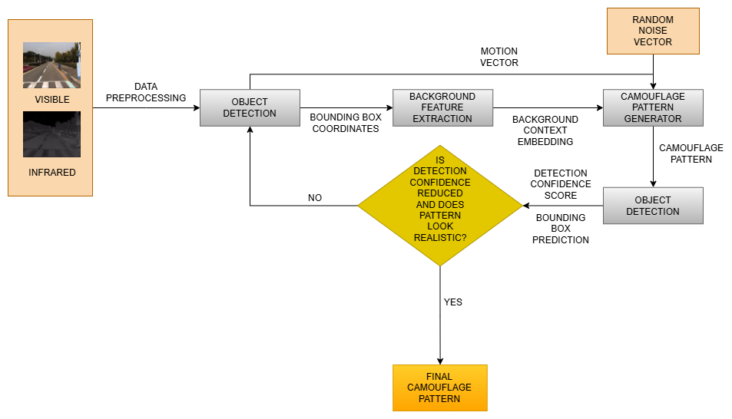
Figure 7.1: Overall framework of the research methodology
The generated camouflage pattern is again run through pre-trained detectors for evaluation. If the generated pattern fails in misleading the detector and looks realistic, the training continues till the results are satisfactory.

MULTISPECTRAL DATASET PREPARATION
The proposed system uses the KAIST Multispectral Pedestrian Dataset by Hwang et al. (2015), which provides us with paired RGB and Infrared images, captured in real-world urban environments. These images allow the study of camouflage effectiveness across visible (RGB) which is used by standard surveillance, computer vision systems and humans, as well as thermal (IR) which is commonly used in nighttime surveillance and autonomous driving.
The dataset preparation stage produces paired visible and IR frame sequences, ready for object detection and background context extraction.
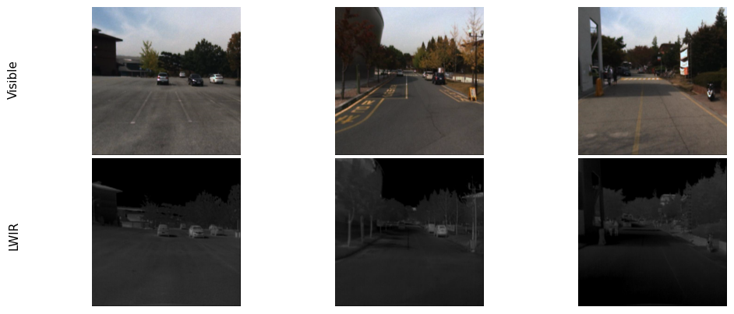
Fig 7.1.1: Paired dataset prepared from the KAIST Multispectral Pedestrian Dataset. The image shows visible images in the first row and its corresponding IR image in the second row.

OBJECT DETECTION AND TARGET REGION INDENTIFICATION
The pretrained object detectors are used on each frame to identify the target object region. The aim of this stage is to:
- Locate the object region where camouflage will be applied.
- Provide object detection confidence scores, which will later be used in adversarial optimization.
Detectors incorporated during training will be an ensemble of YOLO based object detectors, such as YOLOv8 by Varghese and M. (2024) and Faster R-CNN by Ren et al. (2016)
Utilizing multiple object detectors during training forces the framework to generalize for unseen detectors as well rather than focus on attacking one type of detector. Soft NMS algorithm by Bodla et al. (2017) is then used to improve detection accuracy.
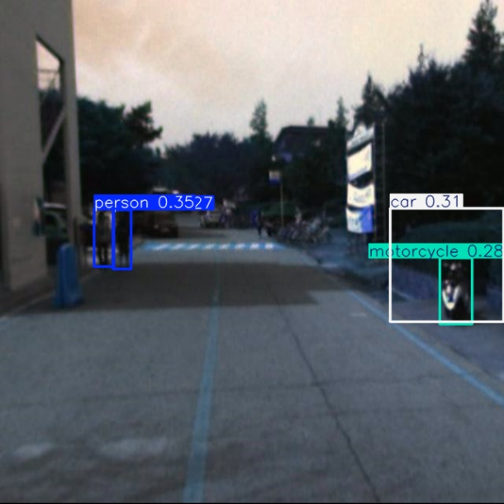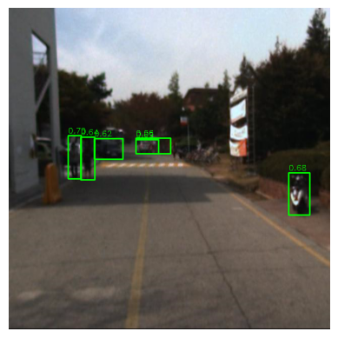
Fig 7.2.1: Detections achieved by YOLOv8 model (left) and by Faster R-CNN (right)
The output of this stage includes axis-aligned bounding box coordinates of the objects and detection confidence scores, which is a product of the probability that the object exists within the bounding box coordinates and the probability of the class identification.

BACKGROUND CONTEXT EXTRACTION
To generate realistic camouflage patterns, the model needs to first understand the visual context of the object’s surroundings.
Once the target object is detected, the corresponding bounding box is utilized to define a local context window. This is achieved by expanding the bounding box by a fixed predefined scale to capture the immediate surrounding.
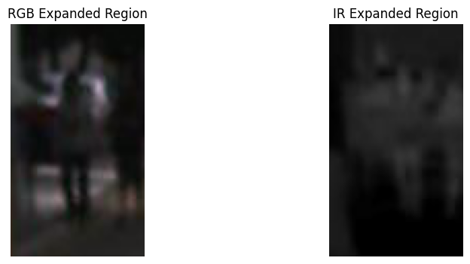
Fig 7.3.1: Expanded region from the bounding box coordinates
To ensure the background features does not include the object itself, we will mask the pixels of the objects original bounding box. This masking process isolates the immediate background region while preventing the object’s appearance from influencing the background representation. From this region, the system derives the following:
- Dominant colours
- Texture statistics
- Spatial patterns
- Thermal intensity distributions
These background features are encoded using a convolutional feature extractor, producing a context embedding vector, representing the local environment. This is then used as conditioning input to the camouflage pattern generator.
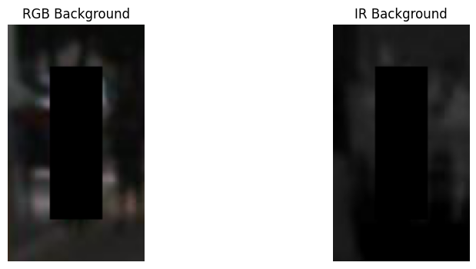
Fig 7.3.2: Extracted background context with the actual object (pedestrians) masked
The goal of this step is to ensure that generated patterns visually and thermally blend with the surrounding scene.

CONTEXT CONDITIONED CAMOUFLAGE PATTERN GENERATION
The core component of the framework is a deep generative model that produces camouflage textures conditioned on environmental context.
The generator receives three major inputs, namely the background context embedding, random latent noise vector, and the actual cropped image of the pedestrian. The random noise is a simple random numerical vector to introduce a source of randomness into the training, so that the patterns generated are stochastic instead of deterministic.
These inputs are used to synthesize a camouflage texture map, that:
- Matches the surrounding background appearance
- Contains adversarial perturbations that disrupts object detectors
For the generator, we are focusing on cGAN. The reason behind choosing cGAN over a diffusion based generative model or an encoder-decoder based generative model are cGANs are relatively lightweight. cGANs draw inference faster than a diffusion based generative model and produces more realistic textures than an encoder-decoder based generator.
The generated output is a camouflage texture that can be mapped onto object’s surface. Since the generator operates on a per-frame basis, the resulting pattern changes dynamically as the object moves through different backgrounds.

CAMOUFLAGE TEXTURE APPLICATION
Once the pattern is generated, it is mapped onto the object surface. The process includes texture scaling to match the object size, spatial alignment with bounding box, which we will be applying via masking, and blending with original object appearance. Blending is achieved by alpha blending, which is a weighted combination of original object pixels and camouflage texture.
To improve realism, smoothness and colour consistency may be applied during blending.

DETECTOR EVALUATION AND ADVERSARIAL FEEDBACK
The modified frame is evaluated using the pretrained object detectors. For each frame the detectors provide the following, namely Detection confidence scores, Bounding box predictions and Feature activations.
These are used to compute an adversarial loss, which measures how successful the camouflage pattern is at reducing detection. These losses further guide the training process of the camouflage pattern generator.

OPTIMIZATION AND MODEL TRAINING
The generator is trained using gradient-based optimization, where the adversarial loss is backpropagated through the pipeline. The training objective is to produce camouflage patterns that can simultaneously:
- Reduce detection accuracy
- Maintain visual realism
- Adapt to changing environmental context
Over multiple training iterations, the model learns to generate robust dynamic camouflage patterns, capable of degrading detector performance across various backgrounds and sensing modalities.

ANALYSIS

INTRODUCTION
This chapter presents the preliminary analysis done prior to the evaluation of the proposed framework. The analysis includes EDA, hyperparameter selection and tuning, and the experimental setup used to evaluate the performance of the proposed framework.

DATA ANALYSIS
The KAIST dataset by Hwang et al. (2015) comprises of paired images from visible and infrared domain. The dataset contains a total of 50,185 pairs of images derived from frames of surveillance footage of pedestrians recorded from vehicle mounted cameras. Upon analyzing the dataset, it is found that quite a few image pairs lack the pedestrians, rendering them useless for experimentation purposes.
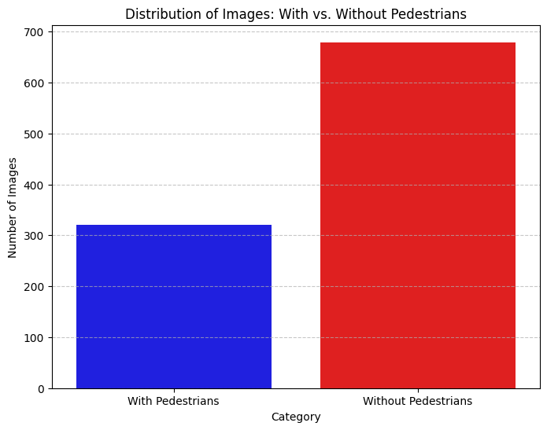
Fig 4.2.1: Bar plot distribution of images with pedestrians vs images without pedestrians over a random sample of 1000 images.
Hence, only the images with pedestrians detected by the pretrained detector models are compiled into the final training dataset, which turned out to be around 13,336 pairs of visible and infrared images. It is also found that majority of the pedestrians have a bounding box with
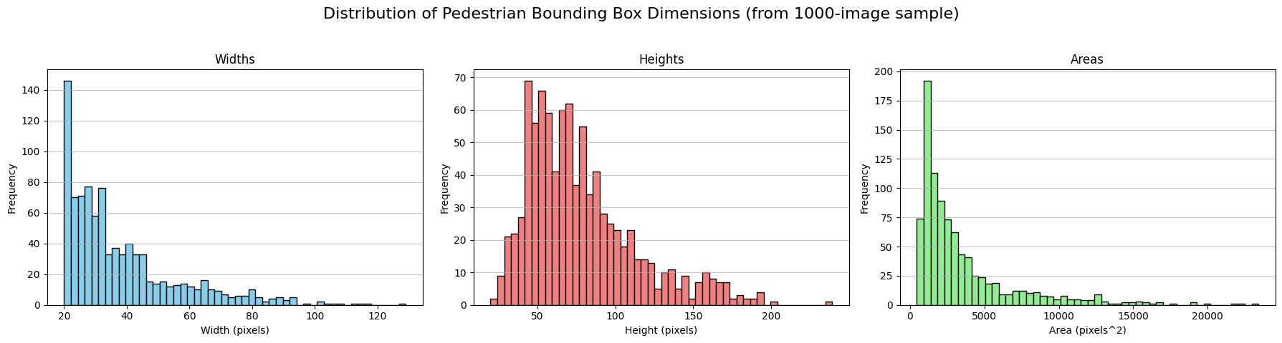
Fig 4.2.2: Histogram plot of the height, width and area distribution of the bounding boxes over a random sample of 1000 images.
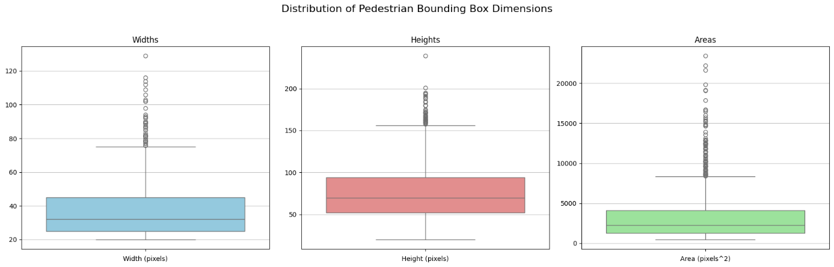
Fig 4.2.3: Box plot of height, width and area distribution of the bounding boxes over a random sample of 1000 images.
mean height of around 38 pixels, mean width of around 78 pixels and mean area of around 3498 square pixels, when inspected over a random sample of 1000 images. This could infer that majority of the pedestrians in the dataset occupy a relatively small area in the images.
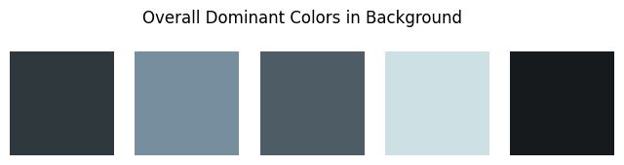
Fig 4.2.4: Dominant colours found in the background of the images in the visible spectrum.

The dominant colours seen in the background of the visible images are in the darker spectrum with black and greyish hue being the most dominant ones. The dominant colours in the background of the pedestrians in the visible images being darker can be explained as majority
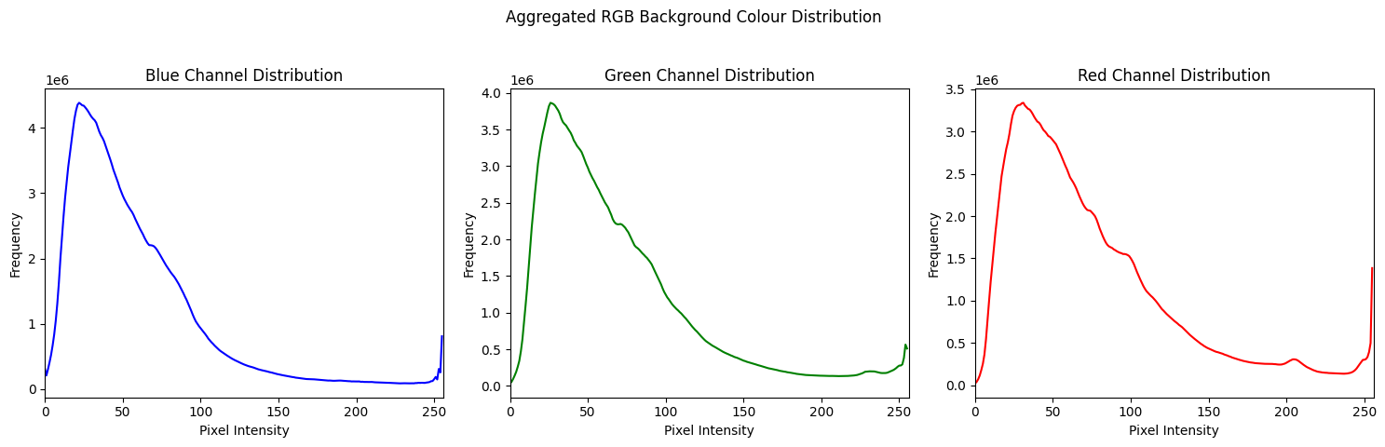
Fig 4.2.5: RGB pixel intensity found in the background of visible images.
of the background consist of asphalt from roads or sidewalks, shades and shadows of trees and the pedestrians themselves, etc. As for the images from the infrared spectrum, the mean thermal intensity in the background is around 50 with a standard deviation of around 24, which can be
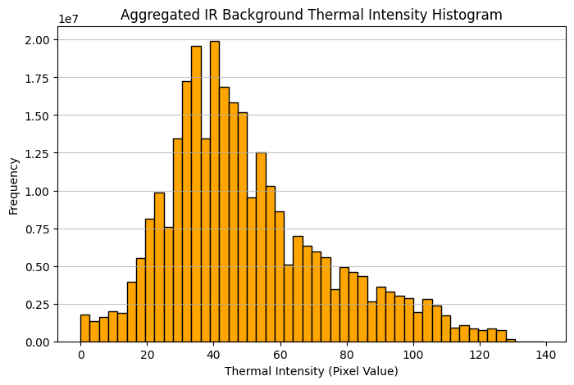
Fig 4.2.6: Thermal intensity in the background of the images from the infrared spectrum.
explained since majority of the objects in the background, i.e. roads, trees or any relatively empty space lacks the distinct heat signatures when compared to ones found in humans or any other living beings.
For a random sample of 300 images with pedestrians, it is found that more than one-third of the
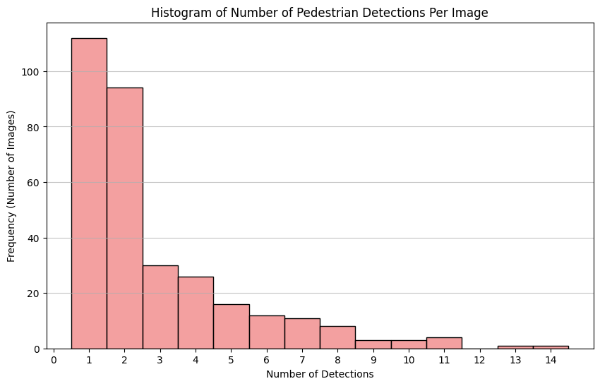
Fig 4.2.7: Histogram plot of number of pedestrians detected over a random sample of 300 images.
images contain single pedestrian. Though there are images found in the sample with more than 3 pedestrians, the count is significantly less compared to single or 2 pedestrians. The confidence scores also range from 0.3 to 1.0, proving the detectors are fairly confident in their detections.
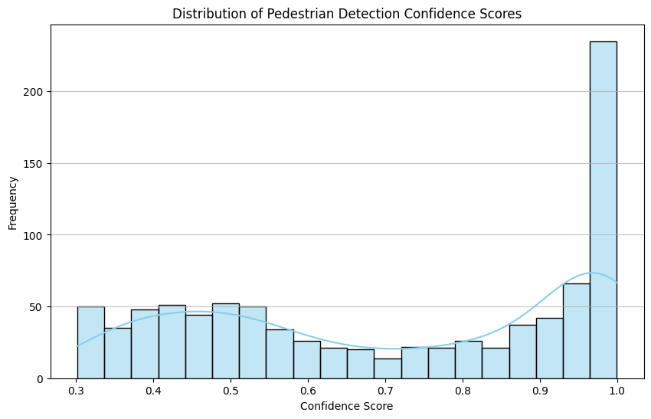
Fig 4.2.8: Histogram plot of confidence score distribution over a sample of 300 images with pedestrians.

HYPERPARAMETER TUNING
HYPERPARAMETER | VALUE | EXPLANATION
img_size | (640, 640) | The images from both the visible and infrared spectrum are standardizerd to make subsequent processing efficient and fast without compromising quality.
train-test split | 0.8 | Having a train-test split of 80-20% provides a significant chunk of data for the training set while keeping manageable amount of images for validating the framework.
conf_thresh | 0.3 | A confidence threshold of 0.3 is applied to YOLO filter out any detections that could possible be false positives and detections that would not be able to provide much to the training cycle after first round of camouflage pattern application.
conf_thresh | 0.5 | A confidence threshold of 0.3 is applied to Faster R-CNN filter out any detections that could possible be false positives and detections that would not be able to provide much to the training cycle after first round of camouflage pattern application.
iou_thresh | 0.5 | A intersection-over-union threshold of 0.5 is kept for a balanced overlap requirement.
sigma | 0.5 | Sigma parameter for the Soft-NMS algorithm. A value of 0.5 is kept to keep the suppression of overlapping boxes’ confidence score balanced.
yw | 0.5 | Weight given to the confidence score component provided by YOLO. 0.5 is chosen to as the weight to keep the contribution of YOLO and Faster R-CNN similar in the detection loss.
fw | 0.5 | Weight given to the confidence score component provided by Faster R-CNN. 0.5 is chosen to as the weight to keep the contribution of YOLO and Faster R-CNN similar in the detection loss.
context_dim | 566 | The dimension of the context vector to the generator.
Learning Rate (Generator) | 5e-5 | The learning rate for the Adam optimizer used to train the generator.
Learning Rate (Discriminator) | 5e-6 | The learning rate for the Adam optimizer used to train the discriminator.
alpha | 0.4 | The blending factor for applying the camouflage. A relatively lower alpha is chosen to balance realism of generated pattern and original image.
Batch size | 32 | A batch size of 32 is chosen to balance GPU utilization and stabilization of gradient updates.
Table 4.3.1: List of hyperparameters, their chosen values and the significance of said hyperparameters and the reason behind choosing said values.

EXPERIMENT DETAILS
The experimentation was done using Google Colaboratory (Colab) with the high RAM runtime configuration. NVIDIA A100 GPU was used to accelerate computationally intensive tasks such as data preprocessing, object detection, feature extraction and model training.
Libraries/Softwares | Versions
Python | 3.12.13
Numpy | 2.0.2
Matplotlib | 3.10.0
Tensorflow | 2.20.0
Torch | 2.11.0+cu128
Torchvision | 0.26.0+cu128
Ultralytics | 8.4.80
Opencv-python | 4.13.0.92
Scikit-learn | 1.6.1
Seaborn | 0.13.2
Pandas | 2.2.2
Table 4.4.1: List of Libraries/softwares and their versions
Libraries and other softwares along with their versions are detailed in the table 4.4.1.
Before the training process, the dataset was pre-processed to ensure consistency across all image pairs. Bounding box coordinates were extracted by feeding the pre-processed images to the ensemble of the YOLO and Faster R-CNN. Corresponding background context was then obtained for subsequent feature extraction.
Training was performed for 50 epochs using Adam optimizer, with a learning rate of 5e-5 for the generator and 5e-6 for the discriminator. A batch size of 32 was chosen to achieve a balance between stable model convergence and computational efficiency.
Performance evaluation was conducted using pretrained object detection models operating on both visible and thermal image modalities. The effectiveness of the generated camouflage patterns was assessed by comparing detector performance before and after camouflage application. Evaluation was based on metrics including detection confidence degradation, detection accuracy reduction, precision, recall, mean Average Precision (mAP) and other relevant performance indicators. Comparative experiments were also carried out against baseline approaches to determine the relative effectiveness and robustness of the proposed dynamic camouflage generation framework under varying scene conditions.

SUMMARY
This chapter presented the analysis undertaken to support the development and evaluation of the proposed dynamic camouflage generation framework. An exploratory data analysis of the KAIST multispectral pedestrian dataset was conducted to examine the characteristics of the visible and thermal image pairs, pedestrian annotations and background information used throughout the study. The chapter also described the selection of training hyperparameters and the rationale behind their configuration to achieve stable model convergence. Finally, the experimental environment, software tools, hardware specifications and evaluation protocol were outlined to ensure the reproducibility of the research. The analyses and experimental settings presented in this chapter establish the foundation for the implementation and evaluation of the proposed framework, which is discussed in the following chapter.

RESULTS AND DISCUSSIONS

CONCLUSION AND RECOMMENDATIONS

REFERENCES
Bodla, N., Singh, B., Chellappa, R. and Davis, L.S., (2017) Improving Object Detection With One Line of Code. CoRR, [online] abs/1704.04503. Available at: http://arxiv.org/abs/1704.04503.
Brown, T.B., Mané, D., Roy, A., Abadi, M. and Gilmer, J., (2018) Adversarial Patch. arXiv.org. Available at: https://www.proquest.com/working-papers/adversarial-patch/docview/2073828578/se-2?accountid=12118.
Chen Shang-Tse and Cornelius, C. and M.J. and C.D.H. (Polo), (2019) ShapeShifter: Robust Physical Adversarial Attack on Faster R-CNN Object Detector. In: F. and G.T. and H.N. and I.G. Berlingerio Michele and Bonchi, ed., Machine Learning and Knowledge Discovery in Databases. Cham: Springer International Publishing, pp.52–68.
Cott, H., (1940) Adaptive_Coloration_in_Animals. The Geographic Journal.
Duan, R., Ma, X., Wang, Y., Bailey, J., Qin, A.K. and Yang, Y., (2020) Adversarial camouflage: Hiding physical-world attacks with natural styles. In: Proceedings of the IEEE/CVF conference on computer vision and pattern recognition. pp.1000–1008.
Hoory, S., Shapira, T., Shabtai, A. and Elovici, Y., (2020) Dynamic adversarial patch for evading object detection models. arXiv preprint arXiv:2010.13070.
Hwang, S., Park, J., Kim, N., Choi, Y. and Kweon, I.S., (2015) Multispectral pedestrian detection: Benchmark dataset and baseline. In: 2015 IEEE Conference on Computer Vision and Pattern Recognition (CVPR). pp.1037–1045.
Liu, X., Yang, H., Liu, Z., Song, L., Li, H. and Chen, Y., (2018) Dpatch: An adversarial patch attack on object detectors. arXiv preprint arXiv:1806.02299.
Nguyen, T.T.P., Gulrez, T., Culpepper, J.B., Le, H.T. and Phung, S.L., (2024) CamoDiff: A Few-shot Diffusion-based Method for Camouflage Pattern Generation. Authorea Preprints.
Ren, S., He, K., Girshick, R. and Sun, J., (2016) Faster R-CNN: Towards Real-Time Object Detection with Region Proposal Networks. Available at: https://arxiv.org/abs/1506.01497.
Suryanto, N., Kim, Y., Larasati, H.T., Kang, H., Le, T.-T.-H., Hong, Y., Yang, H., Oh, S.-Y. and Kim, H., (2023) Active: Towards highly transferable 3d physical camouflage for universal and robust vehicle evasion. In: Proceedings of the IEEE/CVF international conference on computer vision. pp.4305–4314.
Talas, L., Fennell, J., Kjernsmo, K., Cuthill, I., Scott-Samuel, N. and Baddeley, R., (2020) CamoGAN: evolving optimum camouflage with Generative Adversarial Networks. Methods in Ecology and Evolution, 112, pp.240–247.
Thayer Gerald Handerson and Thayer Abbott Handerson, (1909) Concealing-coloration in the animal kingdom; an exposition of the laws of disguise through color and pattern: being a summary of Abbott H. Thayer’s discoveries . [online] New York, The Macmillan Co, 1909. Available at: https://www.biodiversitylibrary.org/item/118302.
Thys, S., Van Ranst, W. and Goedemé, T., (2019) Fooling automated surveillance cameras: adversarial patches to attack person detection. In: Proceedings of the IEEE/CVF conference on computer vision and pattern recognition workshops. p.0.
Varghese, R. and M., S., (2024) YOLOv8: A Novel Object Detection Algorithm with Enhanced Performance and Robustness. In: 2024 International Conference on Advances in Data Engineering and Intelligent Computing Systems (ADICS). pp.1–6.
Wei, Y., Gao, H., Quan, X. and Luo, G., (2024) A transferable adversarial attack against object detection networks. In: 2024 International Joint Conference on Neural Networks (IJCNN). pp.1–8.
Zhu, X., Li, X., Li, J., Wang, Z. and Hu, X., (2021) Fooling thermal infrared pedestrian detectors in real world using small bulbs. In: Proceedings of the AAAI conference on artificial intelligence. pp.3616–3624.
Zhu, Z., Yang, X., Su, H. and Zheng, S., (2025) CamoEnv: Transferable and environment-consistent adversarial camouflage in autonomous driving. Pattern Recognition Letters, 188, pp.95–102.

APPENDIX

APPENDIX A
Our research is divided into multiple milestones which we will be covering over the span of 10 weeks. The detailed plan is as follows:
- WEEK 1: For the first week, we are targeting further detailed literature review and starting with the data preparation. Objectives include in-depth analysis and identifying trends and gaps in recent papers, understanding the KAIST dataset and performing preliminary analysis (if required). Milestone: Finalize available relevant techniques and complete dataset understanding and analysis.
- WEEK 2: The second week will witness the object detection, background context extraction and motion simulation. We will be using YOLO based model for object detection, bounding box and background context extraction. For the motion simulation, we will be doing transformations in the form of translation, rotation and scaling. Milestone: Data pre-processing and preparation.
- WEEK 3: In the third week, we will target to build the Camouflage Generator architecture. We will primarily work with Conditional GAN for the generator and move into diffusion-based model if required or time permits. Milestone: Finalize generator architecture and start generating frame-wise camouflage patterns.
- WEEK 4-5: The fourth week will be focused on adversarial training, where the generated camouflage patterns are applied onto the objects in each frame and loss will be calculated. Milestone: Adversarial training against multiple detectors to significantly reduce detectability.
- WEEK 6: By the sixth week, the training will be completed and we will move onto the evaluation stage. We will use multiple detectors and compare against recent papers to verify the success of the research. Milestone: Evaluation and comparison against recent works and prepare appropriate charts and tables.
- WEEK 7: With the heavy-lifting done, we will move onto drafting the research report. We will be fine-tuning the necessary sections and prepare all figures, charts and tables according to our research journey. Milestone: prepare the full first draft of the research report.
- WEEK 8: The eighth week will be devoted to feedback and refinement process. Necessary revisions according to thesis supervisor’s feedback will be carried out. Milestone: Final revised report with all feedbacks incorporated.
- WEEK 9: The ninth week will be kept as a buffer period to accommodate any unforeseen circumstances.
- WEEK 10: Submission of the research report post preparation of the final document.
The decided timeline is intensive and is designed so each milestone can be achieved within the allocated duration. Risks include potential delays in appropriate architecture selection and design, model training and lower-than-expected results. We have kept a buffer week to accommodate the above-mentioned risks or any other unforeseen events so the final submission deadline remains intact and untouched.

Figure App-A.1: Gantt Chart

APPENDIX B

